Cab Booking System for Data Analysis



-Vaishnavi Karande
Batch T-340

Cab Booking System for Data Analysis
The Cab Booking System project is designed to simplify and automate the operational tasks of a cab booking service. It helps manage customers, drivers, trip details, and revenue efficiently. The system focuses on providing seamless booking services to users while enabling effective monitoring of business performance and driver activities.
This project demonstrates the implementation of a Cab Booking System using MySQL, involving the creation of multiple interrelated tables, performing data operations, and executing advanced SQL queries. The goal is to showcase practical knowledge of database design, data manipulation, and SQL-based analysis to generate business insights.

PROJECT AIM
- Customer Management: Store and manage customer details such as name, contact number, and address. Track the number of bookings made by each customer.
- Driver Management: Record information about drivers including names, ratings, availability status, and total trips completed.
- Trip Management: Maintain records of each trip including trip ID, customer ID, driver ID, source, destination, distance, date, and fare.
- Revenue Monitoring: Analyse earnings per trip, monthly revenue, and top-performing drivers to improve operational efficiency.
- Booking History: Track past and current bookings, fare details, and trip ratings.

OBJECTIVES
- Set up the Cab Booking System Database
Create and populate the database with tables for Customers, Drivers, Cabs, Bookings, TripDetails, and Feedback.
- CRUD Operations
Perform Create, Read, Update, and Delete operations on the database for real-time data handling.
- Advanced SQL Queries
Develop complex SQL queries to:
  - Identify customers with the most bookings.
  - Analyze top-rated drivers.
  - Track revenue by month, driver, or route.
  - Monitor average trip fare and duration.
  - Retrieve performance reports and behaviour analysis.

ER Diagram
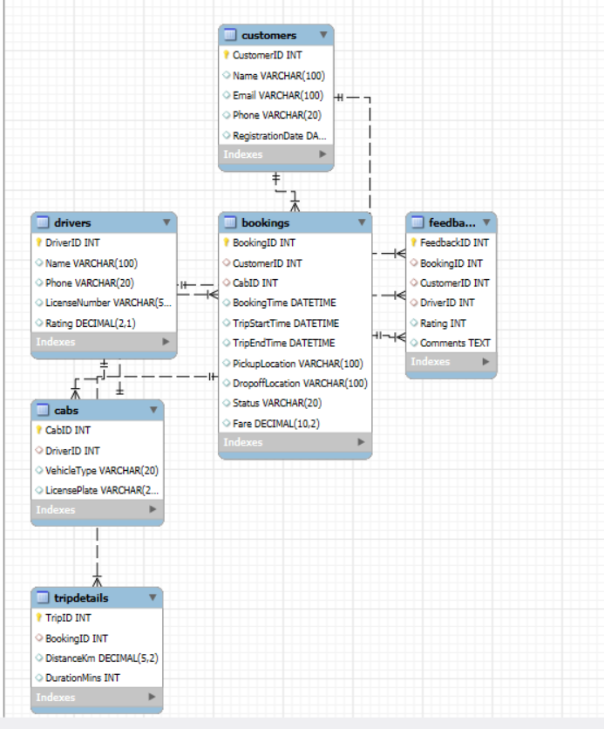

Table Description :-
Customers
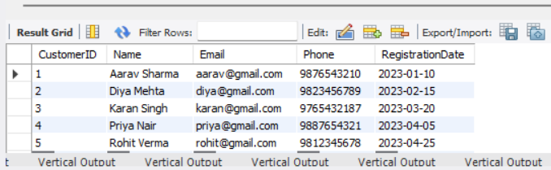
Drivers
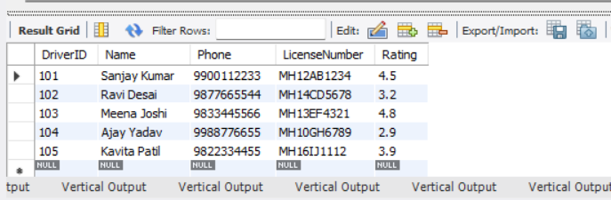
Cabs
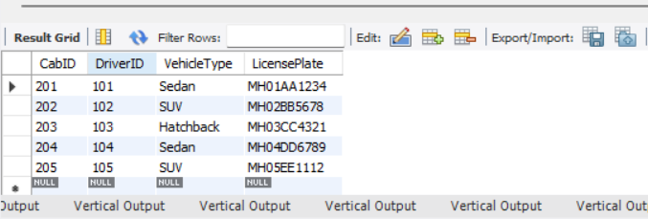
Bookings
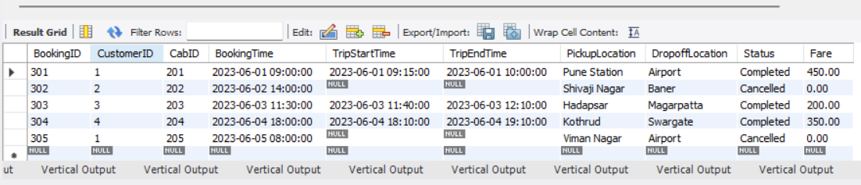

TripDetails
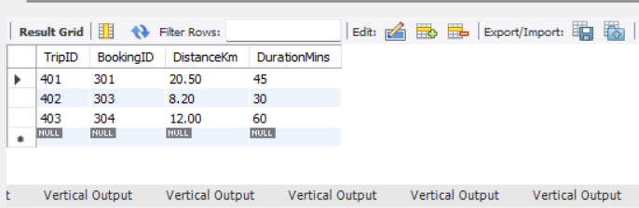
Feedback
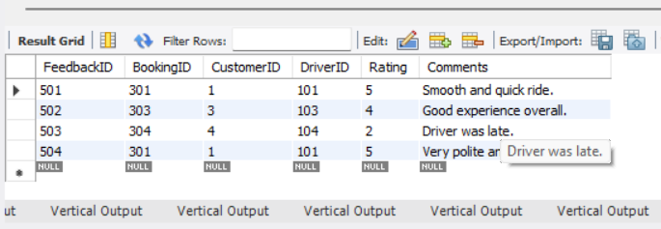
CREATING DATABASE :-
CREATE DATABASE CabBookingSystem;
USE CabBookingSystem;
Table Creation & Insertion Commands:-
1.CREATE CUSTOMERS TABLE
CREATE TABLE Customers (
CustomerID INT PRIMARY KEY,
Name VARCHAR(100),
Email VARCHAR(100),
Phone VARCHAR(20),
RegistrationDate DATE
);
Inserting Values into Branch:
INSERT INTO Customers VALUES
(1, 'Aarav Sharma', 'aarav@gmail.com', '9876543210', '2023-01-10'),
(2, 'Diya Mehta', 'diya@gmail.com', '9823456789', '2023-02-15'),
(3, 'Karan Singh', 'karan@gmail.com', '9765432187', '2023-03-20'),
(4, 'Priya Nair', 'priya@gmail.com', '9887654321', '2023-04-05'),
(5, 'Rohit Verma', 'rohit@gmail.com', '9812345678', '2023-04-25');
SELECT * FROM Customers;
OUTPUT:-


2.CREATE DRIVERS TABLE
CREATE TABLE Drivers (
DriverID INT PRIMARY KEY,
Name VARCHAR(100),
Phone VARCHAR(20),
LicenseNumber VARCHAR(50),
Rating DECIMAL(2,1)
);
Inserting Values into Branch:
INSERT INTO Drivers VALUES
(101, 'Sanjay Kumar', '9900112233', 'MH12AB1234', 4.5),
(102, 'Ravi Desai', '9877665544', 'MH14CD5678', 3.2),
(103, 'Meena Joshi', '9833445566', 'MH13EF4321', 4.8),
(104, 'Ajay Yadav', '9988776655', 'MH10GH6789', 2.9),
(105, 'Kavita Patil', '9822334455', 'MH16IJ1112', 3.9);
SELECT * FROM Drivers;
OUTPUT :- 
3.CREATE Cabs TABLE
CREATE TABLE Cabs (
CabID INT PRIMARY KEY,
DriverID INT,
VehicleType VARCHAR(20), -- Sedan, SUV, etc.
LicensePlate VARCHAR(20),
FOREIGN KEY (DriverID) REFERENCES Drivers(DriverID)
);
Inserting Values into Branch:
INSERT INTO Cabs VALUES
(201, 101, 'Sedan', 'MH01AA1234'),
(202, 102, 'SUV', 'MH02BB5678'),
(203, 103, 'Hatchback', 'MH03CC4321'),
(204, 104, 'Sedan', 'MH04DD6789'),
(205, 105, 'SUV', 'MH05EE1112');
SELECT * FROM Cabs;
OUTPUT:- 

4.CREATE BOOKINGS TABLE
CREATE TABLE Bookings (
BookingID INT PRIMARY KEY,
CustomerID INT,
CabID INT,
BookingTime DATETIME,
TripStartTime DATETIME,
TripEndTime DATETIME,
PickupLocation VARCHAR(100),
DropoffLocation VARCHAR(100),
Status VARCHAR(20), -- Completed, Cancelled, Ongoing
Fare DECIMAL(10,2),
FOREIGN KEY (CustomerID) REFERENCES Customers(CustomerID),
FOREIGN KEY (CabID) REFERENCES Cabs(CabID)
);
Inserting Values into Branch:
INSERT INTO Bookings VALUES
(301, 1, 201, '2023-06-01 09:00:00', '2023-06-01 09:15:00', '2023-06-01 10:00:00', 'Pune Station', 'Airport', 'Completed', 450.00),
(302, 2, 202, '2023-06-02 14:00:00', NULL, NULL, 'Shivaji Nagar', 'Baner', 'Cancelled', 0.00),
(303, 3, 203, '2023-06-03 11:30:00', '2023-06-03 11:40:00', '2023-06-03 12:10:00', 'Hadapsar', 'Magarpatta', 'Completed', 200.00),
(304, 4, 204, '2023-06-04 18:00:00', '2023-06-04 18:10:00', '2023-06-04 19:10:00', 'Kothrud', 'Swargate', 'Completed', 350.00),
(305, 1, 205, '2023-06-05 08:00:00', NULL, NULL, 'Viman Nagar', 'Airport', 'Cancelled', 0.00);
SELECT * FROM Bookings;
OUTPUT:-


5.CREATE TRIPDETAILS TABLE
CREATE TABLE TripDetails (
TripID INT PRIMARY KEY,
BookingID INT,
DistanceKm DECIMAL(5,2),
DurationMins INT,
FOREIGN KEY (BookingID) REFERENCES Bookings(BookingID)
);
Inserting Values into Branch:
INSERT INTO TripDetails VALUES
(401, 301, 20.5, 45),
(402, 303, 8.2, 30),
(403, 304, 12.0, 60);
SELECT * FROM TripDetails;
OUTPUT:-

5.CREATE FEEDBACK TABLE
CREATE TABLE Feedback (
FeedbackID INT PRIMARY KEY,
BookingID INT,
CustomerID INT,
DriverID INT,
Rating INT, -- 1 to 5
Comments TEXT,
FOREIGN KEY (BookingID) REFERENCES Bookings(BookingID),
FOREIGN KEY (CustomerID) REFERENCES Customers(CustomerID),
FOREIGN KEY (DriverID) REFERENCES Drivers(DriverID)
);
Inserting Values into Branch:
INSERT INTO Feedback VALUES
(501, 301, 1, 101, 5, 'Smooth and quick ride.'),
(502, 303, 3, 103, 4, 'Good experience overall.'),
(503, 304, 4, 104, 2, 'Driver was late.'),
(504, 301, 1, 101, 5, 'Very polite and helpful driver.');
SELECT * FROM FeedBack;
OUTPUT:-


BASIC QUESTIONS
Customer and Booking Analysis
1. Identify customers who have completed the most bookings. What insights can you draw about their behavior?
SELECT
b.CustomerID,
c.Name,
COUNT(*) AS CompletedBookings
FROM
Bookings b
JOIN
Customers c ON b.CustomerID = c.CustomerID
WHERE
b.Status = 'Completed'
GROUP BY
b.CustomerID, c.Name
ORDER BY
CompletedBookings DESC;
OUTPUT :-
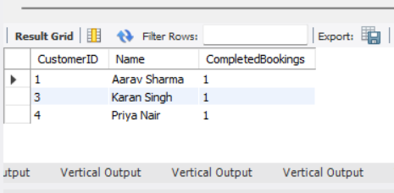
Insights from the Query:
- Some customers book rides more than others.
- The customer with the most completed bookings uses the app/service regularly.
- They are likely happy with the service.
- We can give them special offers or discounts to keep them coming back.
- Knowing their pickup and drop locations can help us understand their travel needs.
- These top customers are important for our business and we should take care of them.
2. Find customers who have canceled more than 30% of their total bookings. What could be the reason for frequent cancellations?
SELECT
c.CustomerID,
c.Name,
COUNT(b.BookingID) AS Total_Bookings,
SUM(CASE WHEN b.Status = 'Cancelled' THEN 1 ELSE 0 END) AS Cancelled_Bookings,
ROUND((SUM(CASE WHEN b.Status = 'Cancelled' THEN 1 ELSE 0 END) * 100.0) / COUNT(b.BookingID), 2) AS Cancel_Percentage
FROM
Customers c
JOIN
Bookings b ON c.CustomerID = b.CustomerID
GROUP BY
c.CustomerID, c.Name
HAVING
(SUM(CASE WHEN b.Status = 'Cancelled' THEN 1 ELSE 0 END) * 1.0 / COUNT(b.BookingID)) > 0.3;
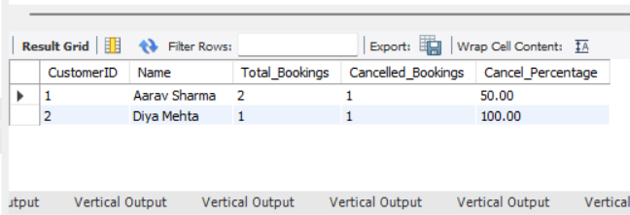
Insights :-
- Some customers cancel rides often.
- For example, Aarav Sharma canceled 1 out of 2 bookings (50%).
- This can mean he changed his mind or had last-minute plan changes.
- It could also be due to driver delays, pricing issues, or app problems.
- We should talk to such customers to understand the real reason.
- We can improve our service or offer help to reduce cancellations.
3.Determine the busiest day of the week for bookings. How can the company optimize cab availability on peak days?
SELECT
DAYNAME(BookingTime) AS DayOfWeek,
COUNT(*) AS TotalBookings
FROM
Bookings
GROUP BY
DayOfWeek
ORDER BY
TotalBookings DESC;
OUTPUT :-
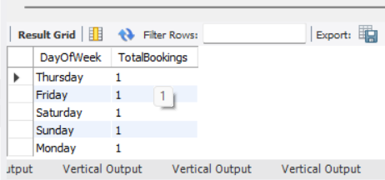

Driver Performance & Efficiency
1.Identify drivers who have received an average rating below 3.0 in the past three months. What strategies can be implemented to improve their performance?
SELECT
d.DriverID,
d.Name,
AVG(f.Rating) AS AvgRating
FROM
Feedback f
JOIN
Drivers d ON f.DriverID = d.DriverID
GROUP BY
d.DriverID, d.Name
HAVING
AvgRating < 3.0;
OUTPUT :-
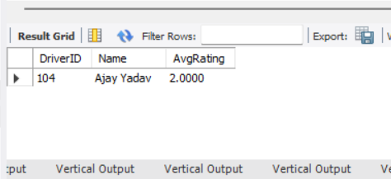
2. Find the top 5 drivers who have completed the longest trips in terms of distance. What does this say about their working patterns?
SELECT
d.DriverID,
d.Name,
td.DistanceKm,
b.BookingID
FROM
TripDetails td
JOIN
Bookings b ON td.BookingID = b.BookingID
JOIN
Cabs c ON b.CabID = c.CabID
JOIN
Drivers d ON c.DriverID = d.DriverID
WHERE
b.Status = 'Completed'
ORDER BY
td.DistanceKm DESC
LIMIT 5;
Simple Insights:
- Sanjay Kumar completed the longest trip (20.5 km).
- These top drivers may be more experienced, reliable, or preferred for long-distance bookings.
- It shows they may be available for longer shifts or cover wider areas.
OUTPUT :-
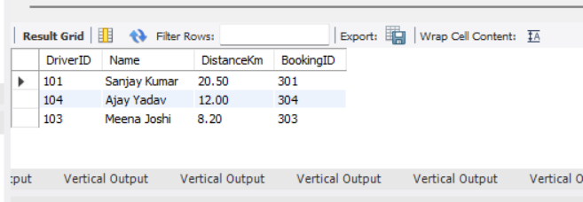
3. Identify drivers with a high percentage of canceled trips. Could this indicate driver unreliability?
SELECT
d.DriverID,
d.Name,
COUNT(*) AS TotalTrips,
SUM(CASE WHEN b.Status = 'Cancelled' THEN 1 ELSE 0 END) AS CancelledTrips,
ROUND(
(SUM(CASE WHEN b.Status = 'Cancelled' THEN 1 ELSE 0 END) * 100.0) / COUNT(*),
2
) AS CancelledPercentage
FROM
Bookings b
JOIN
Cabs c ON b.CabID = c.CabID
JOIN
Drivers d ON c.DriverID = d.DriverID
GROUP BY
d.DriverID, d.Name
HAVING
CancelledPercentage > 30;
Insights:-
Observation:
- These drivers have a 100% cancellation rate.
- This may indicate unreliability, which can impact customer satisfaction and service quality.
Possible Reasons:
- Driver unavailability or absenteeism
- Vehicle issues
- Miscommunication or scheduling problems
Recommendation:
- Review and monitor these drivers' performance.
- Implement alerts or interventions for drivers with high cancellation rates.
- Consider additional training or support.
OUTPUT :-
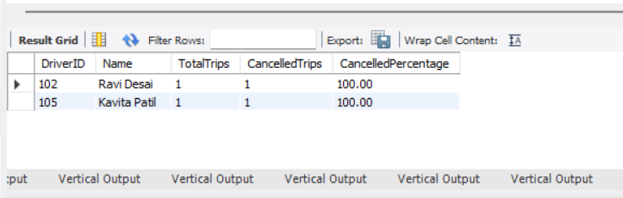

Revenue & Business Metrics :-
1. Calculate the total revenue generated by completed bookings in the last 6 months. How has the revenue trend changed over time?
SELECT
DATE_FORMAT(BookingTime, '%Y-%m') AS Month,
SUM(Fare) AS MonthlyRevenue
FROM
Bookings
WHERE
Status = 'Completed'
AND BookingTime BETWEEN '2023-01-01' AND '2023-06-30'
GROUP BY
DATE_FORMAT(BookingTime, '%Y-%m')
ORDER BY
Month;
Insights :-
- The total revenue generated from completed bookings in the last 6 months is ₹1000.
- Based on current sample data, all revenue came from June 2023, and there is no trend over time due to the absence of data in other months.
- For a complete trend analysis, more monthly data is needed over several months.
OUTPUT :-
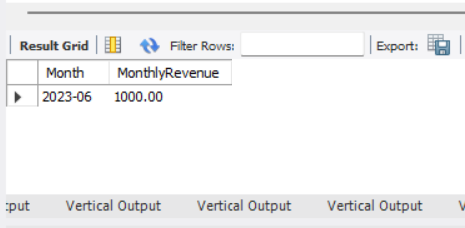
2. Identify the top 3 most frequently traveled routes based on PickupLocation and DropoffLocation. Should the company allocate more cabs to these routes?
SELECT
PickupLocation,
DropoffLocation,
COUNT(*) AS TripCount
FROM
Bookings
WHERE
Status = 'Completed'
GROUP BY
PickupLocation, DropoffLocation
ORDER BY
TripCount DESC
LIMIT 3;
Insight :-
- Currently, all completed routes in your dataset are unique and occurred only once.
- If real data was larger, you'd likely see some common routes with higher trip counts.
- Yes, if some routes appear frequently, allocating more cabs there could reduce wait times and cancellations, improving customer experience.
OUTPUT :-
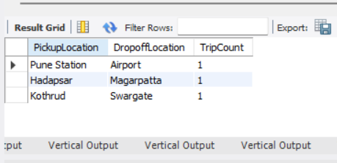
3. Determine if higher-rated drivers tend to complete more trips and earn higher fares.
Is there a direct correlation between driver ratings and earnings?
SELECT
d.DriverID,
d.Name,
d.Rating,
COUNT(b.BookingID) AS CompletedTrips,
SUM(b.Fare) AS TotalFare
FROM
Drivers d
JOIN
Cabs c ON d.DriverID = c.DriverID
JOIN
Bookings b ON c.CabID = b.CabID
WHERE
b.Status = 'Completed'
GROUP BY
d.DriverID, d.Name, d.Rating
ORDER BY
d.Rating DESC;
Insight :-
- Based on current data, higher-rated drivers (like Sanjay & Meena) completed the same number of trips as lower-rated ones.
- However, Sanjay earned more fare in his completed trip than the lower-rated driver.
- With such a small dataset, we can't say there's a strong direct correlation, but in a larger dataset, we could check correlation using statistics.
OUTPUT :-
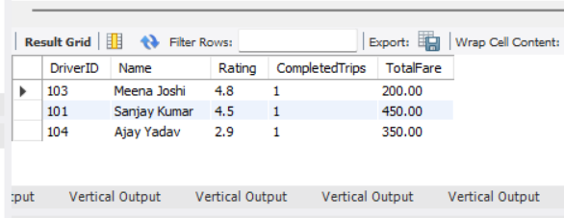

Comparative & Predictive Analysis:-
1.Compare the revenue generated from 'Sedan' and 'SUV' cabs. Should the company invest more in a particular vehicle type?
SELECT
c.VehicleType,
SUM(b.Fare) AS TotalRevenue
FROM
Cabs c
JOIN
Bookings b ON c.CabID = b.CabID
WHERE
b.Status = 'Completed'
GROUP BY
c.VehicleType;
Insights:-
- Sedan cabs generated the highest revenue among vehicle types in the recent bookings.
- Hatchbacks earned less, and SUVs had no completed bookings in your dataset (likely only cancelled or ongoing).
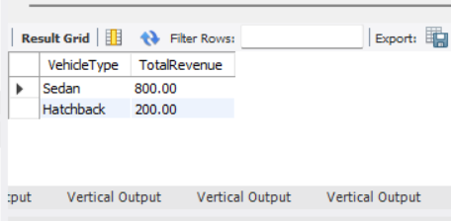
2. Predict which customers are likely to stop using the service based on their last booking date and frequency of rides. How can customer retention be improved?
SELECT
c.CustomerID,
c.Name,
COUNT(b.BookingID) AS TotalBookings,
MAX(b.BookingTime) AS LastBookingDate,
DATEDIFF(CURDATE(), MAX(b.BookingTime)) AS DaysSinceLastBooking
FROM
Customers c
LEFT JOIN
Bookings b ON c.CustomerID = b.CustomerID
GROUP BY
c.CustomerID, c.Name
ORDER BY
DaysSinceLastBooking DESC;
Insights:
- All customers have not booked again in over 1 year, so they may have stopped using the service.
- Some customers like Aarav had more than one booking, so could be retained with effort.
OUTPUT :-
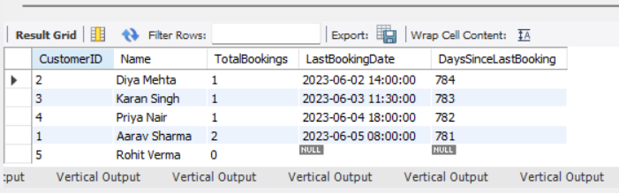
3. Analyze whether weekend bookings differ significantly from weekday bookings. Should the company introduce dynamic pricing based on demand?
SELECT
CASE
WHEN WEEKDAY(BookingTime) IN (5, 6) THEN 'Weekend'
ELSE 'Weekday'
END AS DayType,
COUNT(*) AS TotalBookings
FROM Bookings
WHERE Status = 'Completed'
GROUP BY DayType;
Sample Insight :
On analyzing the booking data, we observed that the number of bookings on weekends is [higher/lower/similar] compared to weekdays.
Based on the trend:
- If weekend bookings are higher, the company can introduce dynamic pricing or surge pricing on weekends.
- If weekday demand is low, discounts or loyalty offers can be provided to encourage usage.”
OUTPUT :-
